**BERNARD MIZEKI GUILD**

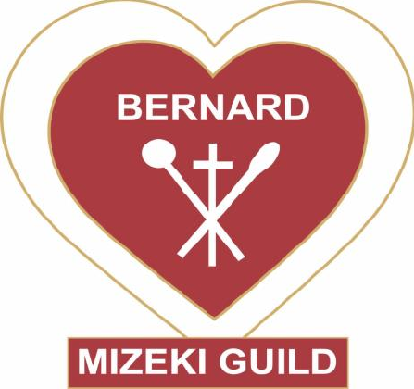

**Name of Representatives:** Graphnot Ruwona & Thompson Jangara

**Mission, Vision & Values of Guild:** The main mission is to follow in the footsteps of the martyr, Bernard Mizeki.

The Guild aims to mobilize the Anglican men into an organized and effective organ of the Church in order to complement the good work being done by other groups in the Church.

To proclaim the Lordship of Christ over all life by preaching the Gospel to all people and to assist the Bishop/Priests and the Parish through giving of members’ time, talents and treasures.

**Hierachy:** Diocesan Executive – President, Vice President, Secretary General, Vice Secretary General, Treasurer & Coordinator.

Archdeaconry Executive – Chairman, Vice Chairman, Secretary, Vice Secretary, Treasurer, Coordinator & Committee members.

**Pictures:**

